

SCHOOL OF MECHANICAL & MANUFACTURING ENGINERRING

NUST

Department of Mechanical Engineering

CS-114 – Fundamentals of Programming

LAB MANUAL #05

**Course Instructor**: Dr Khawaja Fahd Iqbal

**Lab Instructor**: Muhammad Affan

**Student Name**: Muhammad Usman Abdullah

**Section**: B

**CMS ID**: 461513

**DATE**: 30-October-2023

LAB #05 (HOME TASK)

TASK 1:

#include <iostream>

using namespace std;

int main(){

int num1,num2,hcf,lcm,i;

cout<<"Enter the first number: "<<endl;

cin>>num1;

cout<<"Enter the second number: "<<endl;

cin>>num2;

for(i=1;i<=num1 && i<=num2;i++){

if(num1%i==0 && num2%i==0){

hcf=i;

}

}

lcm=(num1*num2)/hcf;

cout<<"The L.C.M of the two numbers is: "<<lcm<<endl;

return 0;

}

OUTPUT:

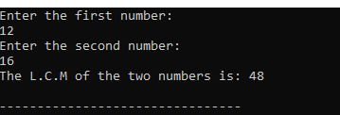

TASK 2:

#include <iostream>

using namespace std;

int main(){

int a,n,d;

float sum;

cout<<"Enter the first term of Arithmetic Progression: "<<endl;

cin>>a;

cout<<"Enter the number of terms you want sum of: "<<endl;

cin>>n;

cout<<"Enter the common difference: "<<endl;

cin>>d;

sum=n/2*((2*a)+(n-1)*d);

cout<<"The sum of "<<n<<" terms of Arithmetic Progression is: "<<sum<<endl;

return 0;

}

OUTPUT:

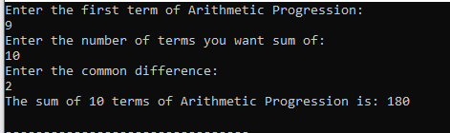

TASK 3:

#include <iostream>

using namespace std;

int main(){

int i;

for(i=1;i<=9;i++){

if(i==1 || i==9){

cout<<" * "<<endl;

}

else if(i==2 || i==8){

cout<<" *** "<<endl;

}

else if(i==3 || i==7){

cout<<" ***** "<<endl;

}

else if(i==4 || i==6){

cout<<" ******* "<<endl;

}

else{

cout<<" ********* "<<endl;

}

}

return 0; }

OUTPUT:

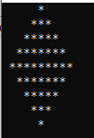

TASK 4:

#include <iostream>

using namespace std;

int main(){

int dec,r,bin=0;

cout<<"Enter a decimal number"<<endl;

cin>>dec;

while (dec>0){

r=dec%2;

dec=dec/2;

bin=(bin*10)+r;

}

cout<<"The decimal number in binary is "<<bin<<endl;

return 0;

}

OUTPUT:

